xGit

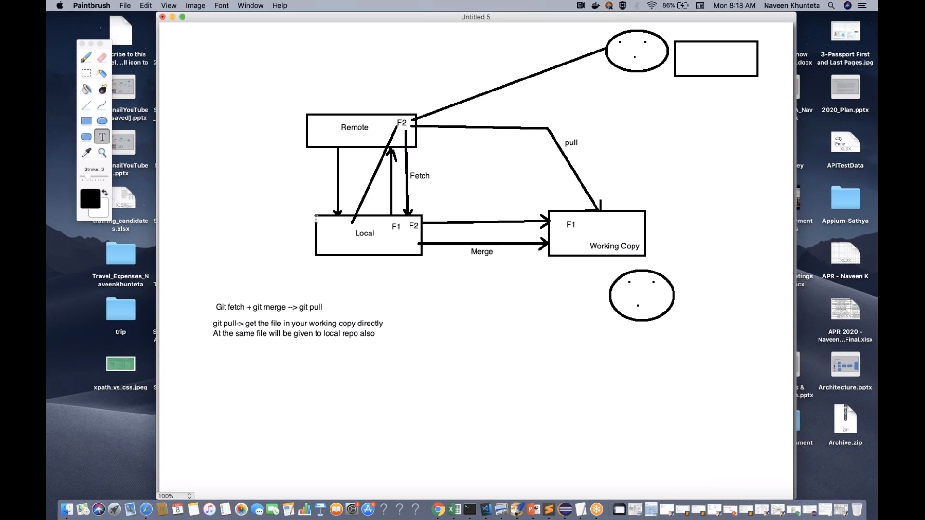

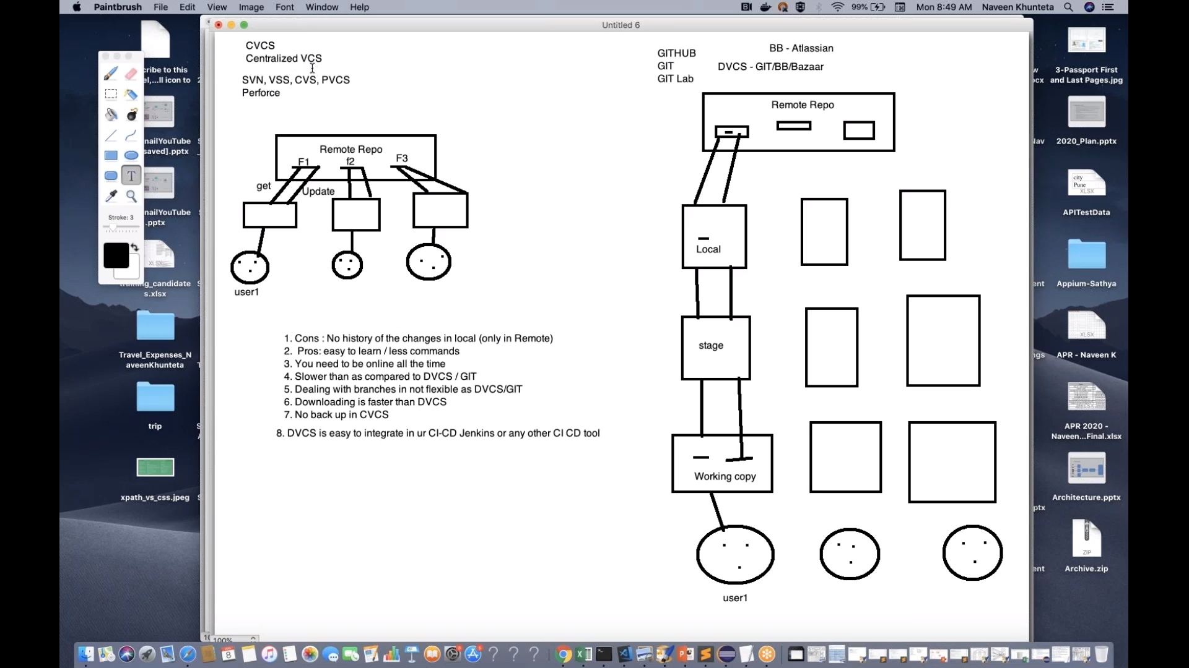

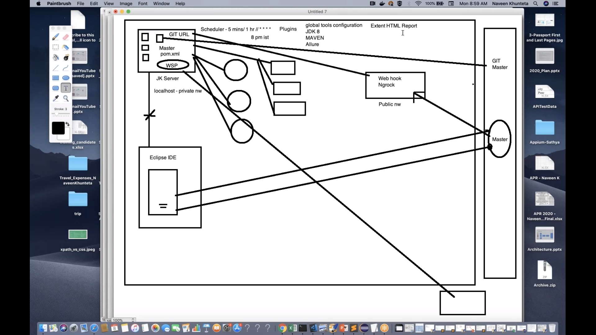

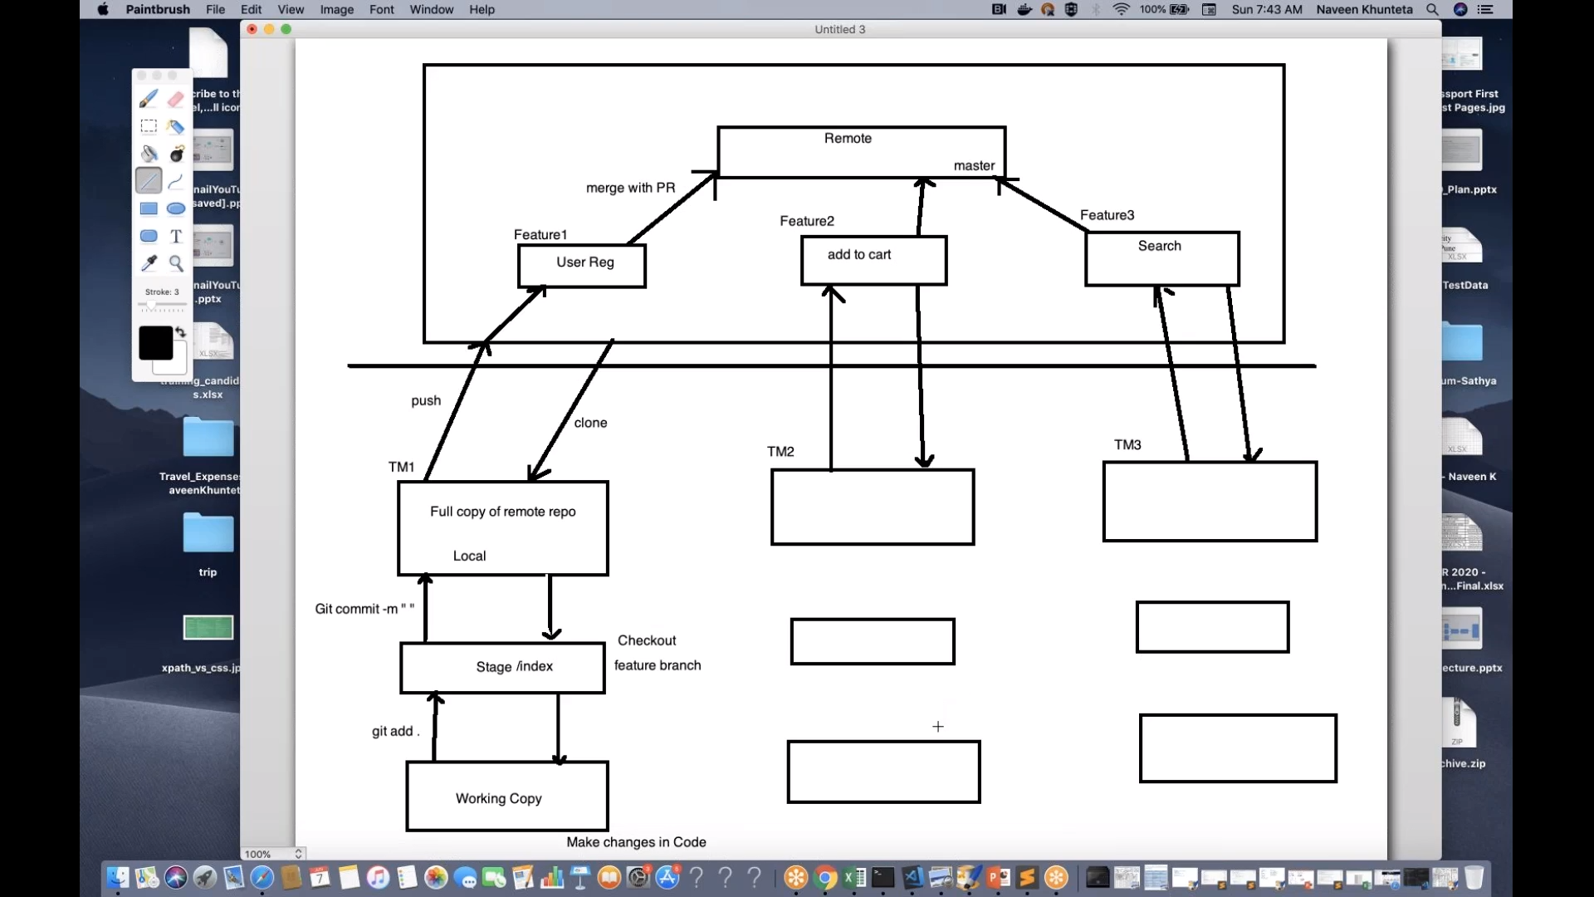

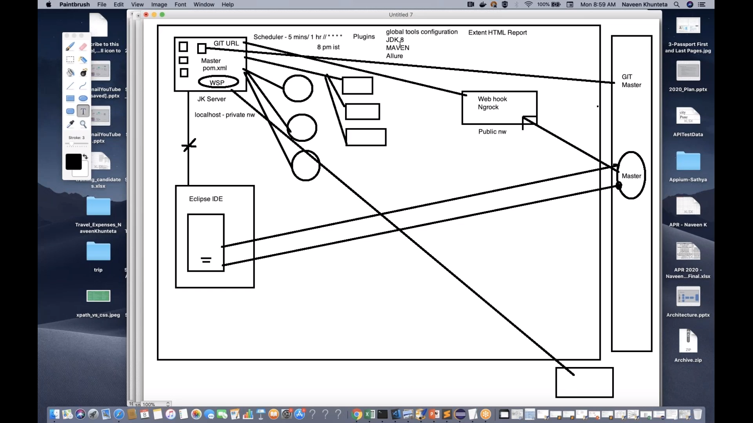

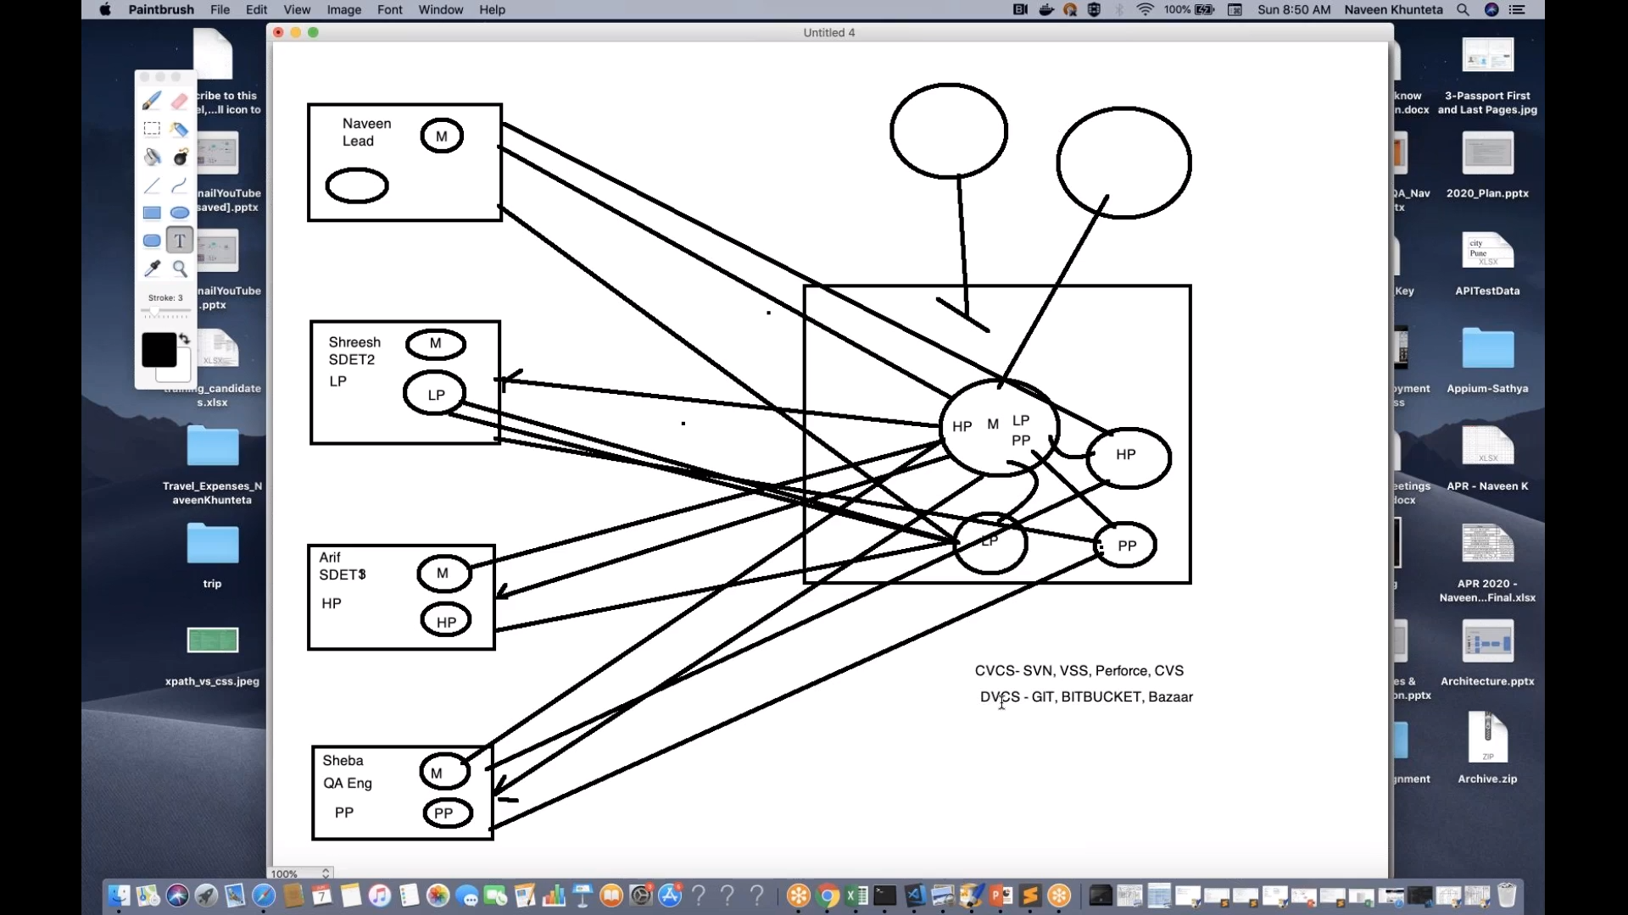

**GIT Steps:**

1. mkdir gitbranchsep2020
2. cd gitbranchsep2020
3. dir
4. git init
5. git remote add origin https://github.com/deepgupta6391/gitbranchsep2020.git
6. if want to check what is inside the .git then follow below steps:
7. cd .git
8. dir
9. cd..
10. git clone <https://github.com/deepgupta6391/gitbranchsep2020.git>
11. git branch
12. notepad file1.txt
13. git status
14. notepad file2.txt
15. notepad file3.txt
16. git add .
17. git status
18. git commit –m “3 files added”
19. git branch
20. git branch userreg
21. git branch
22. git checkout userreg
23. git branch
24. git checkout userreg
25. notepad file1.txt(make changes)
26. git status
27. notepad file4.txt
28. git status
29. git add .
30. git status
31. git commit –m “added new file and modified file1”
32. git push origin userreg
33. git status –s
34. git push –u origin payment
35. **Git notepad notes:**

create and account on github

download git SCM tool - <https://git-scm.com/downloads>

go to ur project directory in eclipse: create .gitignore file

git init

git remote add origin https://github.com/deepgupta6391/HubSpotPOM.git

git status//red

git add .

git status//green

git commit -m "commit reason"

git push -u origin master

git push –f origin master(hard push)

========================================

git clone projectpathingithub --to download

==================================

go to project path and type

git branch

git fetch && git checkout dealspage(for first time)

git merge

git branch

git add src/main/java/com/qa/hubspot/page/DealsPage.java

git commit -m "created deals page"

git push origin dealspage

git branch

git checkout master

**git pull origin master(to copy to local branch from master)**

======================================

Points:

Code cannot be pushed from dealspage to master

code can be pushed from master to master

***********************************************

mkdir gitfetchandpull

notepad file1.txt(touch file1.txt --for mac)

add file2.txt in github directly

git fetch

git merge

and file3.txt in github directly

git pull origin master

mkdir gitcleanSep

notepad file1.txt

file1.txt

more file1.txt

git clean –n

git clean -n -f(after commiting if I don’t want to add files to github, it means file will be removed from local)

git clean -n -d(after commiting if I don’t want to add files to github, it means directory will be removed from local)

git rm file1.txt(to remove the file from working place)

git rm –r src(to remove src directory from the working place)

+++++++++++++++++++++++++++++++++++++++++++++++++++++++++++++++++++++++++++++++++++++++++++++++++++++++++++++++++++++++

GIT Notes:

1) git int

2) git remote add origin [git@github.com:deepgupta6391/Jan2021OpenCartPOM.git](mailto:git@github.com:deepgupta6391/Jan2021OpenCartPOM.git)

3)git status

4)add .gitignore file

5)git status(git status –s)—for shorter message

6)git add .(means add to local)

7)git commit –m “adding reason”(add to in to bucket)

8)git push –u origin master(git push –f origin master(hard push))🡪 -f is hard push and –u is untracked files which are not committed.

9)git clone <https://github.com/deepgupta6391/Jan2021OpenCartPOM>

10)In eclipse goto file🡪 import🡪Maven🡪Existing maven projects🡪click on next🡪browse the project🡪 select the project 🡪click on open🡪select pom.xml ->click on finish

11)To add a single file🡪 git add (path of the file)

12)git pull🡺(git fetch + git merge origin/branchName)

13)git clean -n -f(after commiting if I don’t want to add files to github, it means file will be removed from local)

14)git clean -n -d(after commiting if I don’t want to add files to github, it means directory will be removed from local)

15) git rm file1.txt(to remove the file from working place)

16) git rm –r src(to remove src directory from the working place)

^=#########################################

GIT Notes for PR:

1)git branch(to see all branches)

2)git branch signup(the branch is there in remote but not in local, so to create in ocal this command is written)

3)git checkout signup

Other commands:

1. ls –alt(to see files and folders in that particular folder)

**Local branching process:**

1. create a branch -- signup -- git branch signup

2. switch the branch (sign up) -- git checkout signup

3. *signup & master

4. create/modify ur code <file>

5. git status

6. git add <file>

7. git commit -m "reason"

8. git push origin signup

9. sign up branch is created in Remote

10. Raise a PR at remote

11. PR process and approve it

12. merge at remote to master

13. sign up <file> changes should be reflected in master

================

another team memeber (Ali):

1. take the latest pull from master git pull origin master

2. check the latest changes in master in local

================

Team member has to develop a new feature(Code): 1. repeat: Local branching process

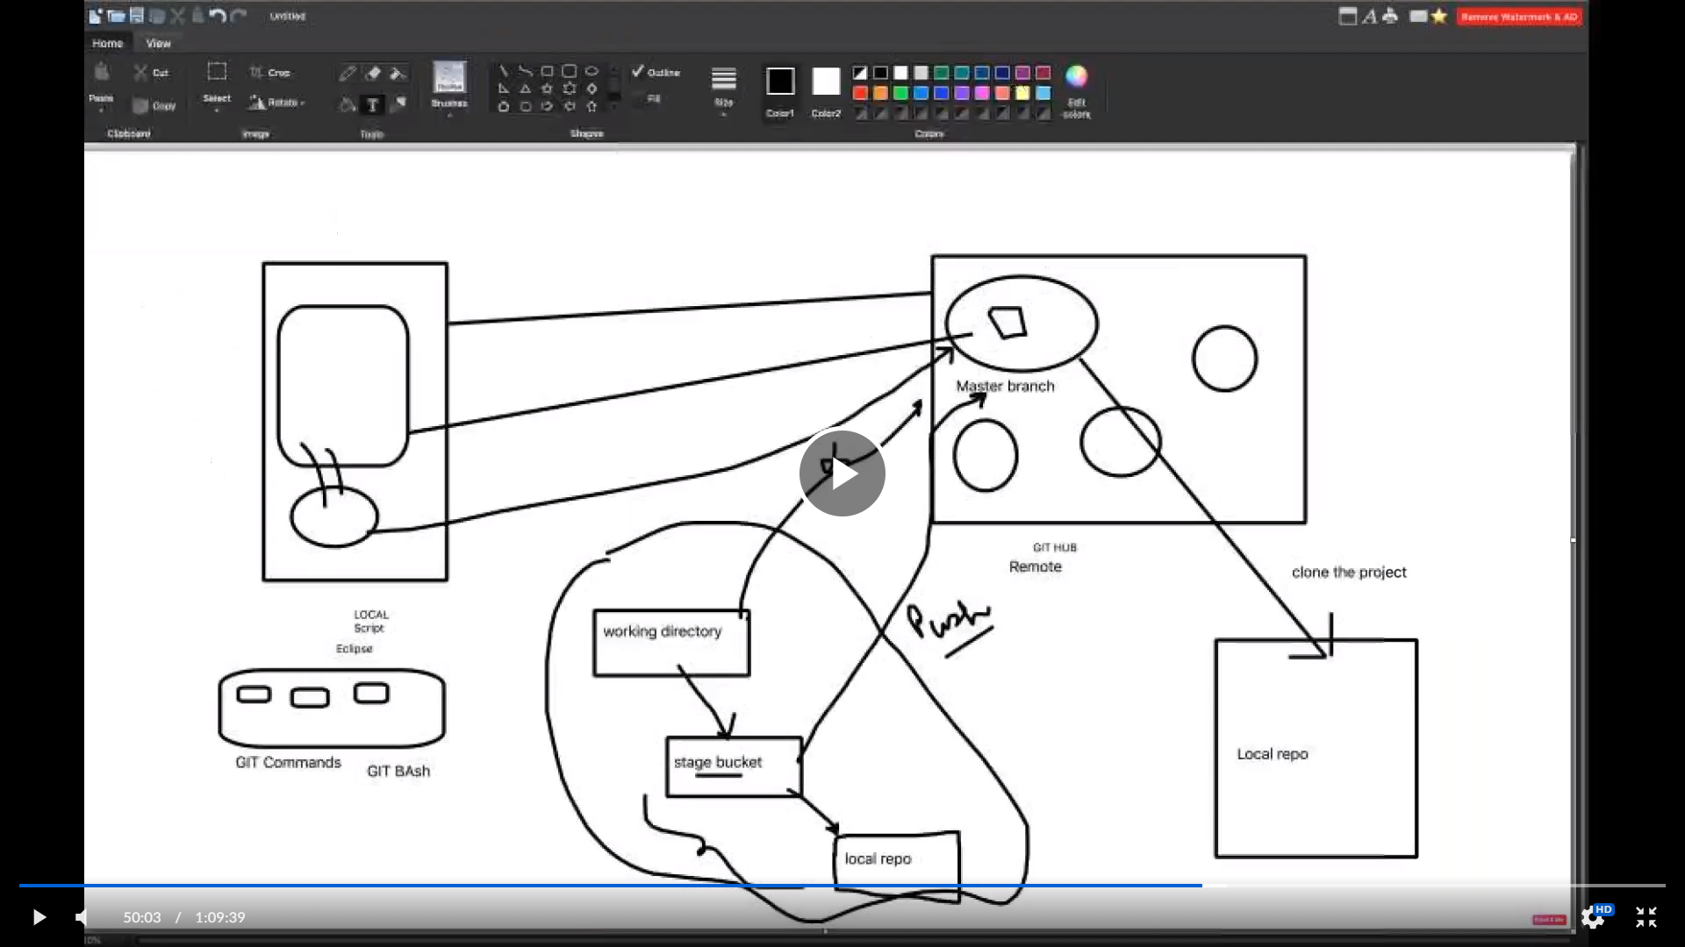

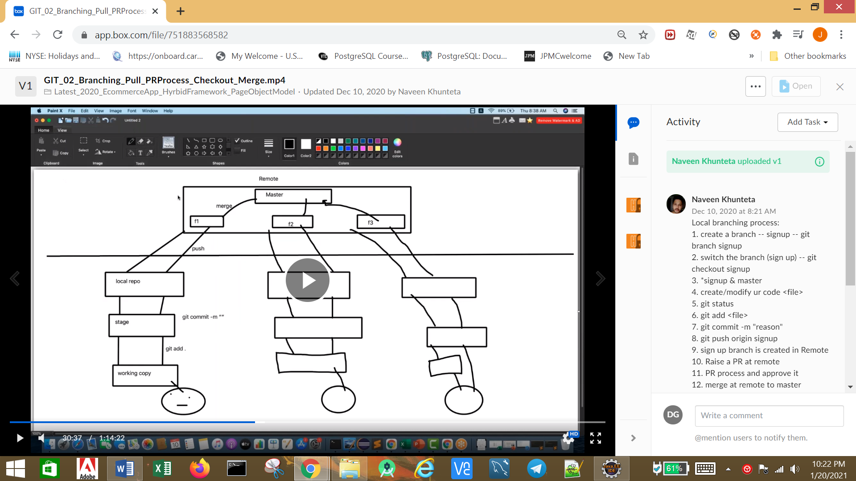

1. **delete branch locally**

git branch -D localBranchName

1. **delete branch remotely**

git push origin --delete remoteBranchName

Jenkins scheduler

1.*/5 * * * --in every 5 mins

2.* 8 * * * -- everyday at 8h00

3.H 7 * * * --daily 7AM

4.H 16 * * 0 -- every sunday 4pm

**C) Unix commands for GIT**

1. cat file1.txt(to print commands in powers shell)
2. git status –s
3. touch file1.txt
4. vim file1.txt(to edit the content in the file)
5. :wq!
6. cat file1.txt
7. git status –s
8. clear
9. ls
10. pwd(present working directory)

**Jenkins:**

1. java –jar jenkins.war –httpPort=8585(to open in specified port)
2. java -Dhudson.model.DirectoryBrowserSupport.CSP="" -jar jenkins.war
3. java -jar jenkins.war
4. .war-web application resource

**Plugins to install in Jenkins:**

Content Security Policy (CSP)—download plugin for extent html report proper display.

1. Global tools configuration:
2. JDK configuration
3. Maven installation
4. Allure setup after adding plugin
5. Manage Plugins:
6. TestNG results Plugin
7. HTML Publisher Plugin
8. Allure Jenkins Plugin
9. Maven integration plugin—if not added by default
10. Blue ocean plugin
11. *************************************
12. LDAP(company username and password)
13. Email Ext
14. Email Ext Recepients Column Plugin
15. Build Pipeline Plugin
16. Pipeline

Ngrok:

ngrok authtoken 1htHXhEnCKoxDXcwNtXLxxBB3fg_QEnkjNRTAJkRNTRw3cTL

ngrok http 8080

<https://7ad62aae9f06.ngrok.io/github-webhook>

https://26a0e1e98b48.ngrok.io/github-webhook/

**Build and Deployment process:**

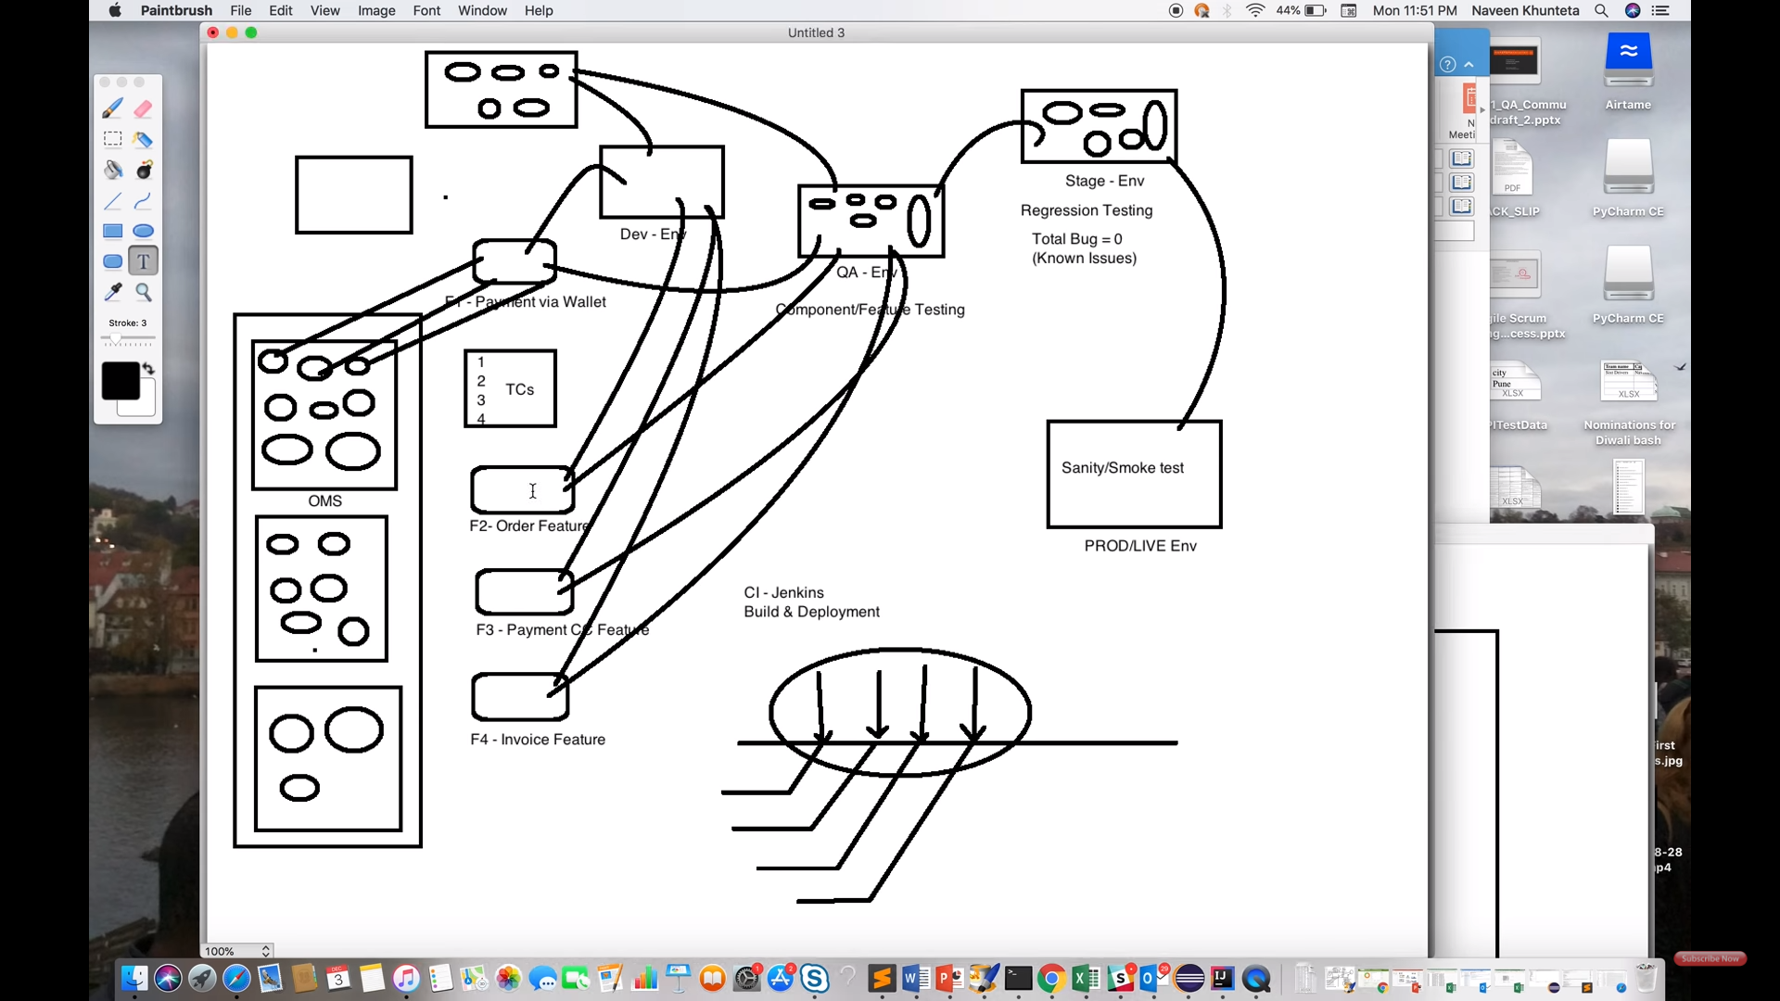

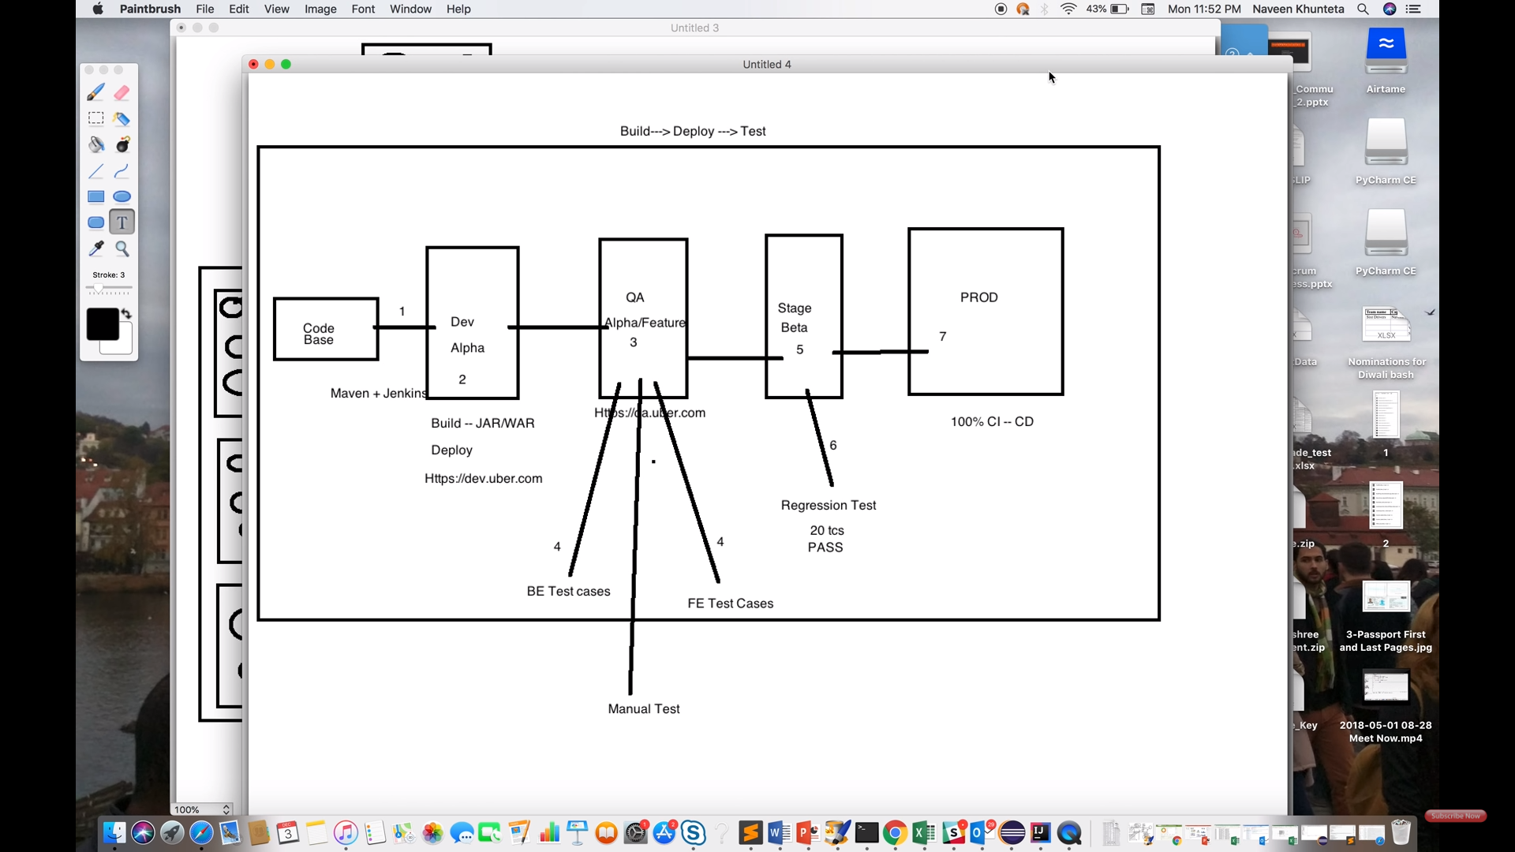

**Docker:**

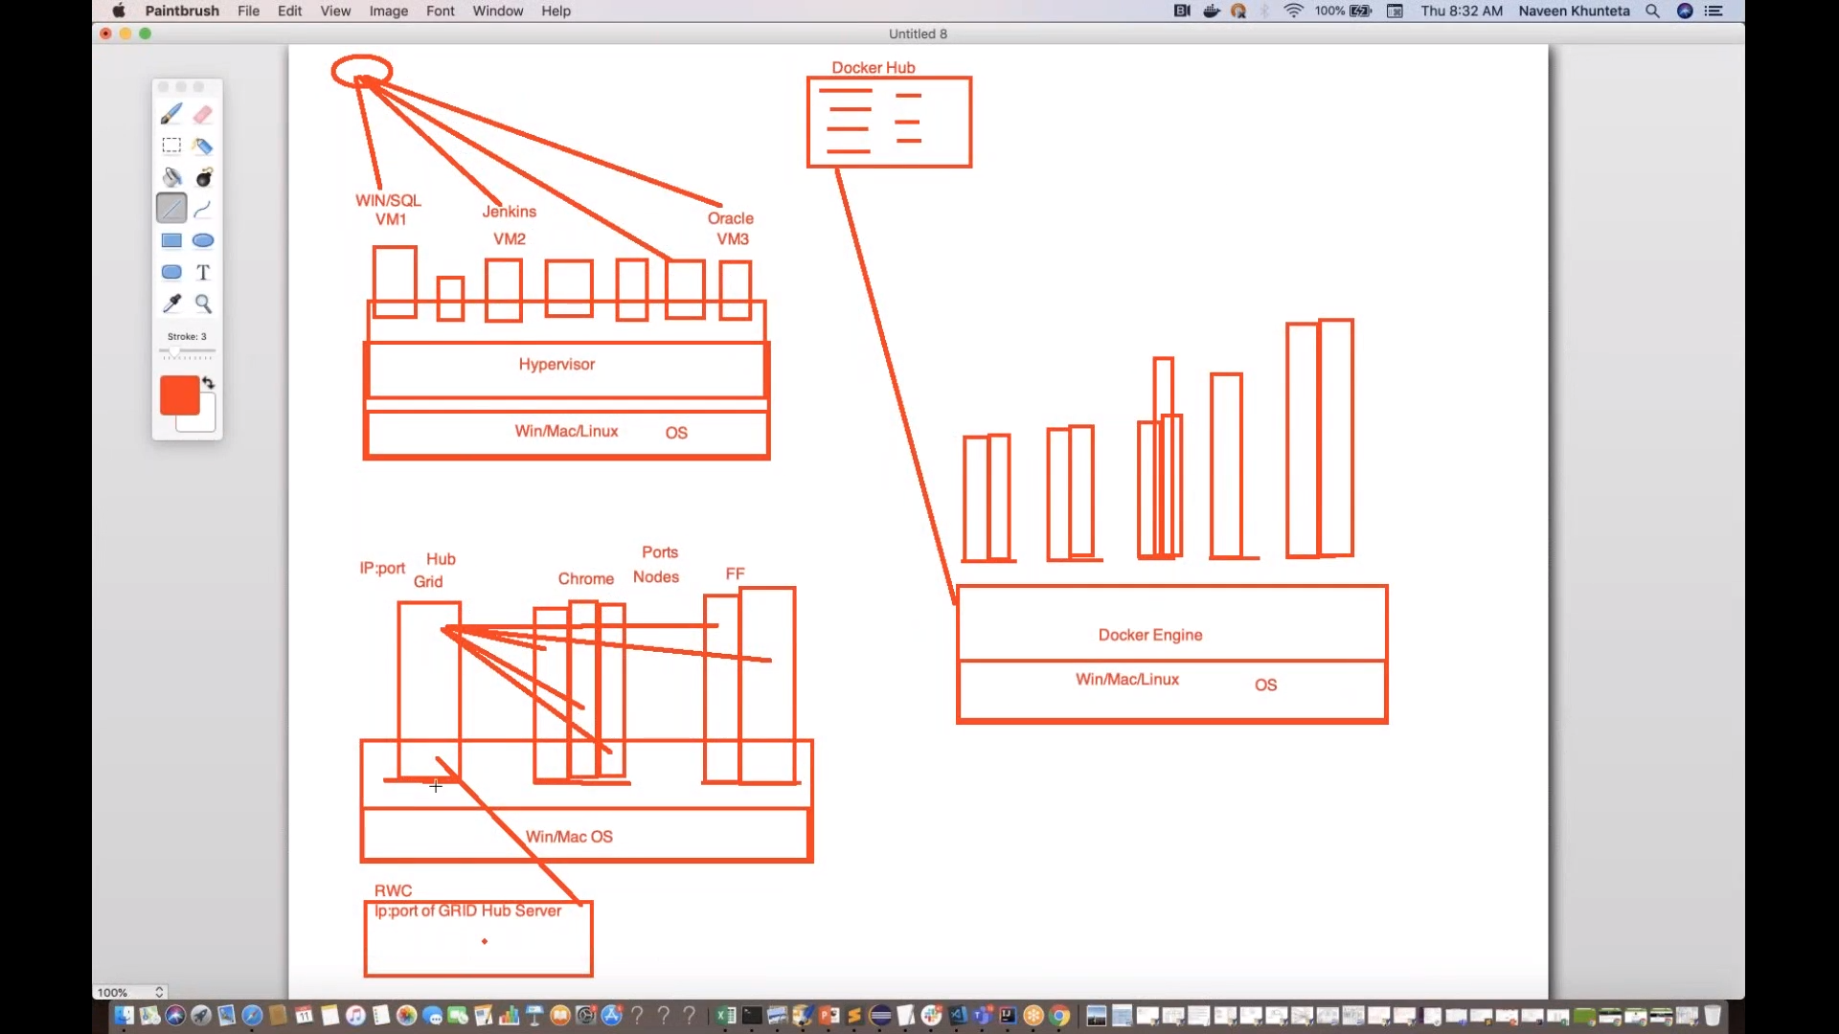

**Docker commands: (https://hub.docker.com)**

1. docker images
2. docker ps -a(give me information of all containers running on sys)
3. docker run –d –p 4444:4444 --name selenium-hub –P selenium/hub(container selenium hub)

-d🡪 don’t show logs or detached mode

-p🡪port

--name🡪name of the image

-P🡪from which image

4. docker ps –a

5. get docker ip: 🡪 docker-machine ip default

6. to connect to image:🡪 docker run –d –P - -link selenium-hub:hub selenium/node-chrome-debug

7. docker logs conrainerID

8. docker kill containerID

9. docker rm containerID(first kill and then remove container)

10. docker rmi imageID

11. docker system prune –a

**Steps followed for docker:**

1. docker pull selenium/hub
2. docker images(for checking the images)
3. docker pull selenium/node-firefox-debug
4. docker ps –a(for checking containers)
5. docker pull selenium/node-chrome-debug
6. docker run –d –p 4444:4444 --name selenium-hub –P selenium/hub

* -d🡪 don’t show logs or detached mode
* -p🡪port
* --name🡪name of the image
* -P🡪from which image

1. => <http://192.168.99.100:4444/>
2. docker run –d –P --link selenium-hub:hub selenium/node-firefox-debug
3. docker ps –a
4. docker run –d –P - -link selenium-hub:hub selenium/node-chrome-debug
5. docker restart containerID
6. docker logs containerID
7. docker stop containerID
8. docker rm containerID
9. docker rmi imageID
10. docker system prune –a

**Docker Compose commands:**

docker-compose –v

docker-compose up(it will pull images)

docker-compose up –d(don’t give logs)

docker-compose scale chrome=3

docker-compose scale firefox=5

docker-compose down

docker-compose ps

docker system prune –a

docker images

docker ps

**Zalenium: (**[**https://opensource.zalando.com/zalenium/**](https://opensource.zalando.com/zalenium/)**)**

[**http://192.168.99.100:4444/grid/admin/live**](http://192.168.99.100:4444/grid/admin/live)

**http://192.168.99.100:4444/dashboard/**

**Selenium Grid Steps:**

Go to selenium standalone server path :

``````CMD---1:

1. java –jar selenium-server-standalone-3.141.59.jar –role hub
2. Then open browser and enter 🡪http://localhost:4444/grid/console

CMD ---2

* java –Dwebdriver.gecko.driver=”F:/Softwares/jars/selenium/geckodriver.exe” –jar selenium-server-standalone-3.141.59.jar –role node –hub <http://192.168.1.167:4444/grid/register>

**Selenoid:**